1. The three madd letters (Harooful Madd) are :
a) ا و ن b) ء ا ى
c) ا و ء d) ا و ى

2. Letters with Harakaat on them are _______ if they are followed by their corresponding Harooful Madd
a) prolonged b)shortened
c) turned to sakin

3. Corresponding harf-e-madd of Fatha
a) ى b) و c) ا

4. A simple harakah (fatha, dhamma or kasrah) is read for _____ beat/beats
a) Two b)One c)Three

5. Madd-e-asli occurs ______ times in 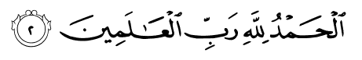
a) Two b)Three
c) One d)Four

6. Leen letters are:
a) وْ , ىْ
b) ى , و
c) ا و ى

7. Madd-e-Leen occurs when there is ____ on the letter preceding Leen letters
a) Fat-hah b)Kasrah
c) Dhammah

8. Madd-e-Leen occurs _____ times in 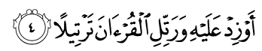
a) One b) Two
c) Three d) Four

9. The word has _____ harakahs
a) 2 b) 3 c) 4
d) 5 e) 6

- Lahn-e-Jali is a mistake that:
  - Is obvious and can be felt.
  - Changes the meaning of the Quran’s words.
  - Is haram.
  - All of the above.
  - None of the above

- Lahn-e-Khafi is a mistake that:
  - Is obvious and can be felt.
  - Changes the meaning of the Quran’s words
  - Is haram
  - All of the above
  - None of the above

- If the word اِنَّ is read “inna” instead of “innnnna” this is
- Lahn-e- Jali
- Lahn-e-Khafi
- None of the above

- The Clear mistakes (Lahn-e-Jali) must be avoided by all and to avoid them one must know the rules of
- Qalqala
- Tajweed
- Madds
- None of the above

