Surah Al-Feel

Name and Meaning of Surah:

Surah Number:

Juz Number:

Number of Ayahs:

***Key Messages & Lessons:***

1: ___________________________________________

_____________________________________________

2: ___________________________________________

_____________________________________________

3: ___________________________________________

_____________________________________________

Surah Al-Feel (The Elephant)

Complete the flow chart for the narrative of Abrahah.

Surah Al-Feel (The Elephant)

Using the words from the Word Bank, retell the story in your own words.

Abrahah Yemen Ka’bah Church Elephant Mahmood

Abdul Muttalib San’aa Quraish pebbles Feel

________________________________________________________________________________________________________________________________________________________________________________________________________________________________________________________________________________________________________________________________________________________________________________________________________________________________________________________________________________________________________________________________________________________________________________________________________________________________________________________________________________________________________________________________________________________________________________________________________________________________________________________________________________________________________________________________________________________________________________________________________________________________________________________________________________________________________________________________________________________________________________________

Surah Al-Feel (The Elephant)

Complete the map below by labelling the countries and drawing labelled arrows showing the steps of the journey.

Makkah Yemen Habashah (Abyssinia)

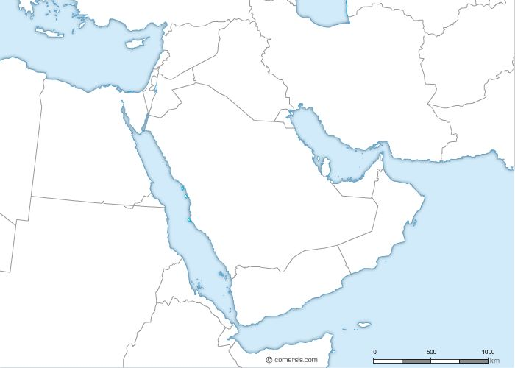

Surah Al-Feel (The Elephant)

Complete the map below by labelling the countries and drawing labelled arrows showing the steps of the journey.

Makkah Yemen Habashah (Abyssinia)

C:\Program Files\Microsoft Office\MEDIA\CAGCAT10\j0301050.wmf

Abrahah attempts to attack the Ka’bah but is unsuccessful

Abrahah takes over Yemen and builds a Church

Abrahah sets out to attack Yemen

Surah Al-Feel (The Elephant)

Learn the key Arabic vocabulary with meaning to help you understand the Surah when you are reciting in Arabic.

|  |  |  |
| --- | --- | --- |
| Arabic | Transliteration | Translation /  Meaning |
| **رَبُّكَ – رَبُّ + كَ** | Rab bu ka | Your Lord |
| **أَصْحَاب** | Ashaab | People / companions |
| **فِيْل** | Feel | Elephant |
| **كَيْد** | Kayd | Plot, evil plan, |
| **تَضْلِيْل** | Tadhleel | Waste / Astray |
| **أرْسَلَ** | Ar sa la | He sent |
| **طَيْر** | Tayr | Bird |
| **أَبَابِيْل** | Abaabeel | Flocks / group |
| **حِجَارَة** | Hijaarah | Stones / pebbles |
| **سِجِّيْل** | Sijjeel | Baked clay |
| **مَاْكُوْل** | Makool | Eaten up |

Surah Al-Feel (The Elephant)

What do we learn about the method of Da’wah from the attempt of Abrahah to build a huge decorated place of worship as a way of encouraging people to accept his faith?

________________________________________________________________

________________________________________________________________

________________________________________________________________

How should we react if someone disrespects our place of worship?

________________________________________________________________

________________________________________________________________

________________________________________________________________

What lessons do we learn from Abraha’s attempt to attack the Ka’bah and the consequences he faced because of it?

________________________________________________________________

________________________________________________________________

________________________________________________________________

How can we apply these lessons to our life today?

________________________________________________________________

________________________________________________________________

________________________________________________________________

________________________________________________________________

________________________________________________________________

Surah Feel (The Elephant)

Miracle in the Elephant: The unique design of the foot of elephants.

Summarise key facts about elephants including the special design of the foot of Elephants



***The special design in an Elephant’s foot***

Surah Feel (The Elephant)

Miracle in the Elephant: The unique design of the foot of Elephants.

Summarise key facts about elephants including the special design of the foot of Elephants.



*Elephants are the largest land creatures alive today*

*Elephants weigh around 5 tonnes*

*Elephant legs are the right size to support their huge weight*

*Elephants weigh around 5 tons*

***The special design in an Elephant’s foot***

Even though the Elephant weighs a huge amount (around 5 tonnes), it makes a small sound and impact because of the special way it has been designed. Under the bones is a special thick tissue which works like a cushion to soften the impact and sound from the Elephant.

***The creation in an Elephant’s foot***

The largest land animal on our planet is the elephant, which weighs about five tons. In order for such a heavy creature to be able to walk, it needs a special design. Elephants have to walk 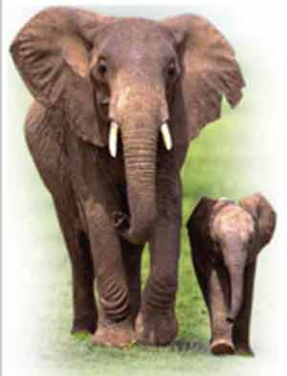long distances to find water, and are equipped for the task with legs that are wonders of engineering. If their legs were a bit thinner, they would not be able to hold the elephant up. But there is an even more interesting design feature in the foot of the elephant. Under the toe bones there is a thick, elastic fatty cushion. The wide sole covered with this fatty cushion distributes the pressure, and the elephant’s weight is spread out evenly over its feet. Because of this, elephants are able to tread very lightly despite their weight. The pressure that an elephant’s foot exerts on the ground is less than that exerted by a woman wearing high-heeled shoes. In short, this is a special shock absorber system designed for elephants.  
  
The fact that the sole of the elephant’s foot has been equipped with a cushioning system shows the existence of a plan. The system was designed how the animal would best be able to walk. And this shows us that there is a Creator Who created this system. This is the creative artistry of Almighty Allah.