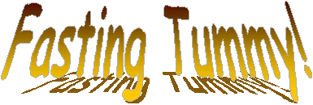
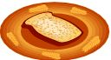
O my tummy! Do not eat!
Be strong this day on your feet!
Leave your drink and leave your meal
And think of how the hungry feel!
O my tummy! Take no drink!
Keep a fast, for others think
Not a drop will reach their lips
Though before you water drips.
We must help the hungry, poor
Give them food and things much more
When we all fast then indeed
We think of those in need!

