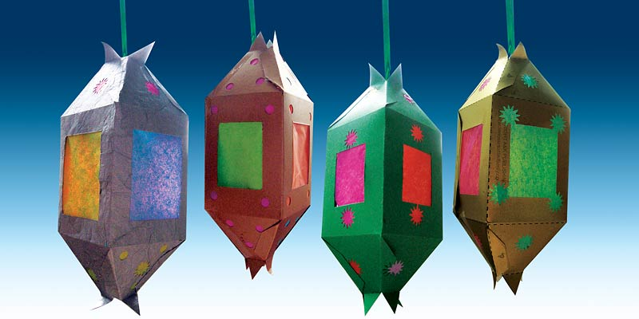
Make a Decorative Fanous!
You can make these fawanee for your home and festoon your windows with these colorful lanterns. You can print our template on to your own colored paper and make some today!
Supplies Needed:
Card stock-you can find a wide variety in craft stores in the scrapbooking section. We used metallic paper but you can use any colors you’d like.
Colored tissue paper
Scissors
Ruler
Pencil
Hole Puncher or craft puncher
Craft knife optional (Adults only!)
Glue stick
- Print out file on card stock or heavy paper, (if your printer will accept heavier paper or card stock, otherwise print it on regular paper and glue it to card stock-be sure to glue entire surface of paper!)
- Cut on the solid lines and score and fold on the dashed lines (score by using a straight edge and a pen and heavily mark on the lines on the inside of your fanous, this makes it easier to fold it up in the end).
- Cut out the gray rectangles or cut any shapes you like, keeping in mind you want the colors to show through when you’re done. You may want to ask an adult to cut them out with a craft knife instead of scissors.
- Use a hole puncher or a craft punch to cut out shapes in the top portions of your lantern.
- Using a glue stick paste around the holes you’ve made and cover them with brightly colored tissue paper.
- Glue or tape a piece of ribbon or yarn to the top of your fanous.
- Coat the inside of the “A” flaps with your glue stick.
- Begin folding your fanous, by lining up the “A” flaps over the “B” flaps-1 through 4.
- You may have to insert a pencil or your finger inside the final flaps so you can press the flap down on something firm.
- Hang your fanous in a sunny window and you’ll see the colors light up!
DO NOT PLACE NEAR A LIGHT OR FLAME!

