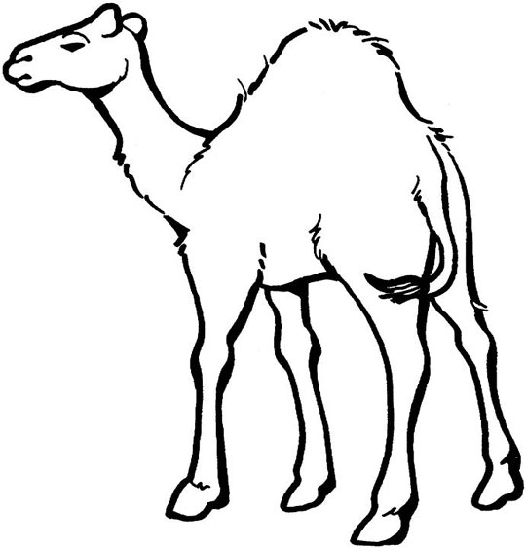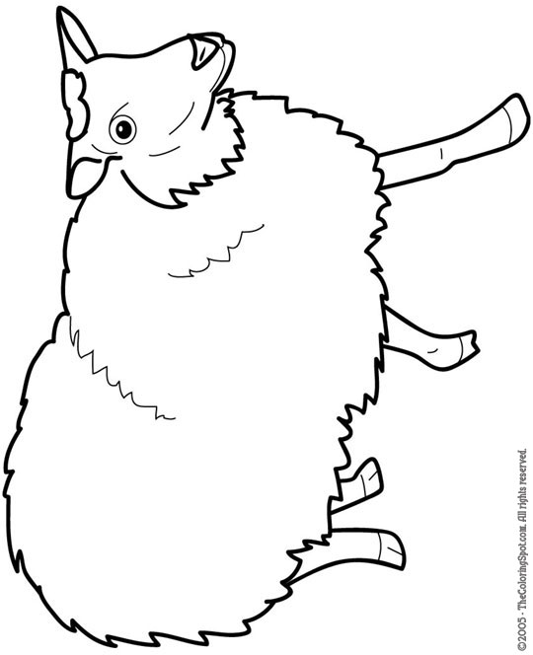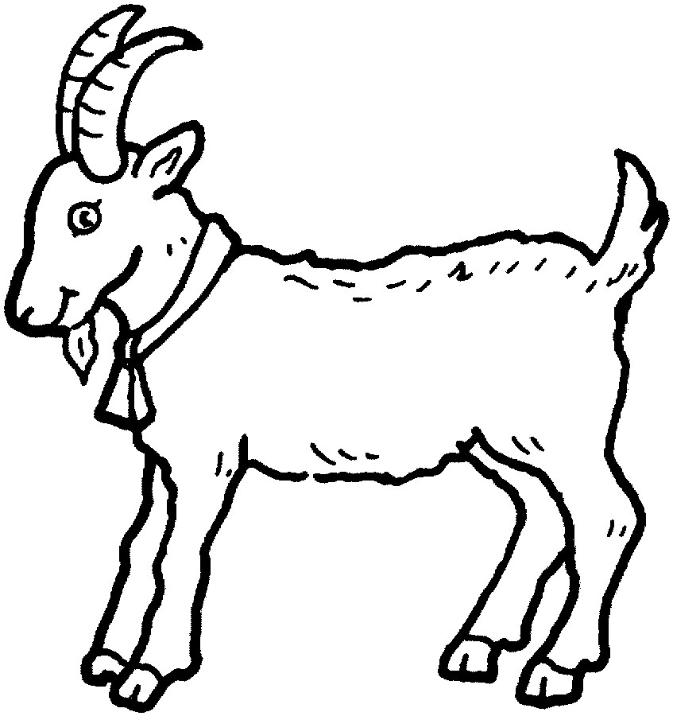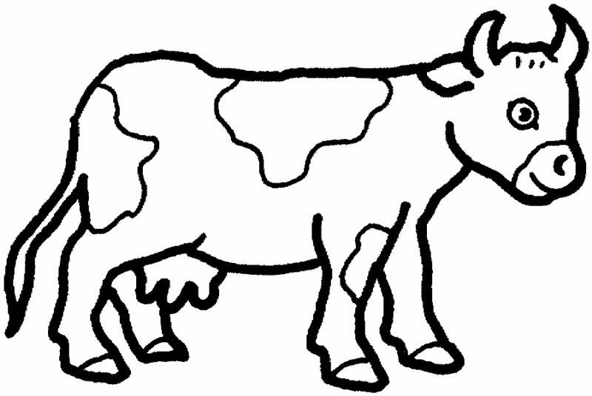

© 2010 Umamah Learning Academy

small big 1 small 1

7 big 7

I am a _____ animal. You can sacrifice me for _____________. I have ___ shares.

I am a _____ animal. You can sacrifice me for _____________. I have ___ shares.

I am a _____ animal. You can sacrifice me for _____________. I have ___ shares.

I am a _____ animal. You can sacrifice me for _____________. I have ___ shares.



Animals we can sacrifice on Eid ul Adha

Fill in the blanks with the words in the word box