Masjid Eid Card

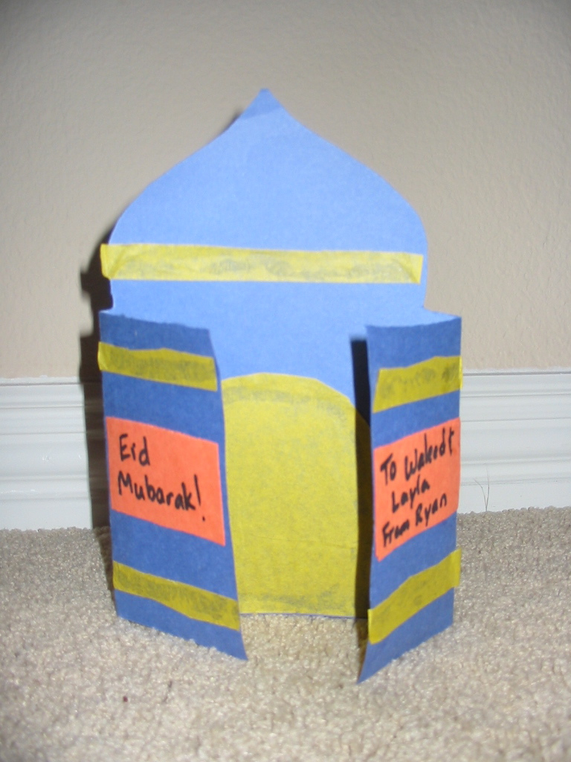
Materials:
Construction paper
Yellow tissue paper
Glue
Scissors
Black marker
Pencil

Directions:

1. Use a pencil to mark the middle of a piece of construction paper. This should be about 6 inches from each end of the paper.

2. Fold the ends of the paper so that they meet in the middle.

3. Cut a dome over the middle section, and cut off the tops of the end sections that are folded over.

4. Cut doors and stripes out of yellow tissue paper. Glue the doors inside the card, and the stripes along the top of the dome and on the outside of the card.

5. Write a message like, “Eid Mubarak” on a piece of construction paper. Cut out the message and glue it to the inside of the card.

