Flashcards: Major Signs of Qiyaamat/Judgement Day

The signs of the final hour can be divided into two groups:
1) Minor signs Minor signs are events of normal nature prophesised by our Prophet Muhammed to take place before Qiyamah like the consumption of alcohol, disrespect of parents, dancing, prevalence of ignorance and immorality and signs of this nature. The majority of the minor signs have appeared while some are occurring and some will appear with major signs.
2) Major signs Major signs are events of extraordinary nature prophesied by our Prophet to take place before Qiyamah. Once these signs appear, the end of the world is known to come very soon thereafter. Some of these have been provided in flashcard form below.

Yaajooj and Maajooj (Gog and Magog)

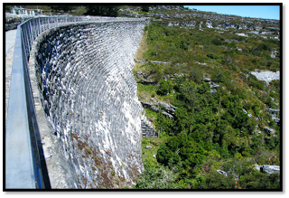

The Beast

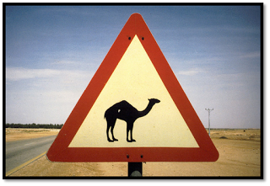

The Fire

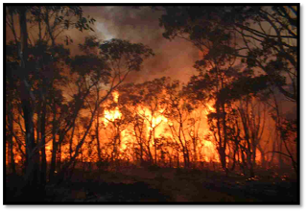

Imam Mahdi alayhissalaam
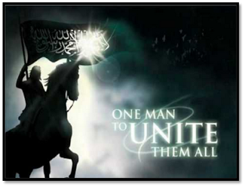

Return of Isa (Jesus) alayhissalaam

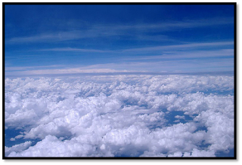

The Smoke

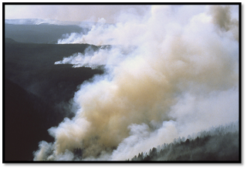

Sun Rising from West

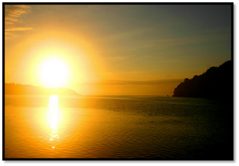
Landslides
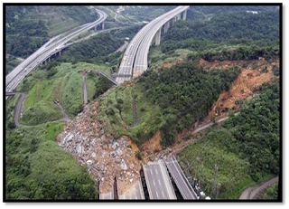

Dajjaal (The Anti-Christ)

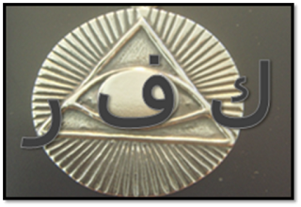

Important:
All of these signs are not in the order of occurance. They are in random order.
These signs are not general. They refer to specific major events. For example, the major sign about landslides refers to 3 major landslides that will happen before Qiyaamah.

The signs can be studied in detail in authentic books.

