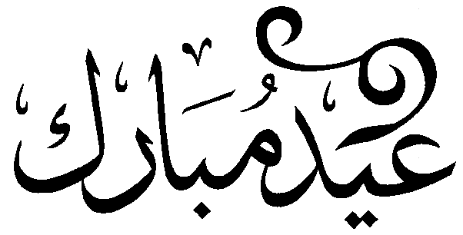

To: _____________
From: _______________

Eid Mubarak!

May you have a blessed
& happy Eid!

