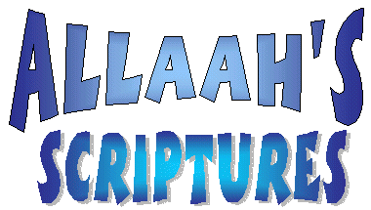
Allaah sent His Messengers
To guide us – me and you
And Allaah gave to them a Book
That showed us what to do
To Prophet Moosa Allaah gave
A Book that showed the way
This Book Allaah had named Tauraat
To follow every day
To Prophet Daawood Allaah gave
A Book that taught things right
This Book Allaah had named Zaboor
To follow day and night
To Prophet ‘Eesa Allaah gave
A Book that made things clear
This Book Allaah had named Injeel
For people far and near
And last Allaah gave Prophet Muhammad [s]
A Book today we find
This book Allaah named al-Qur'aan
To guide us for all time.

