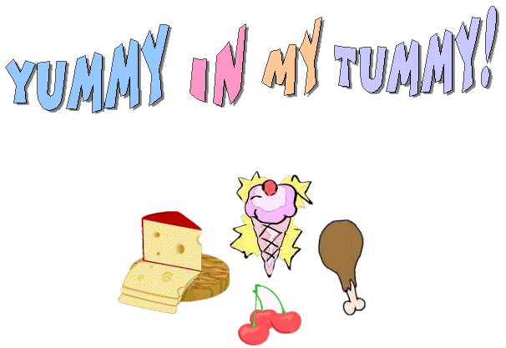
Lots of food for us to taste
They are blessings so don't waste!
Allaah gives us all food good
So eat it up we should!
I thank Allaah for all His favours
Food and drink with many flavours!
Meat and fruit and sweets, all yummy
All things nice for our small tummy!
WHEN YOU FINISH EATING:
Alhamdulillaah-hilladhee at’amanee haadhaa warazaqaneehi min ghayri hawlimminnee wala quwwa
This du’aa means: All Praise is for Allaah who fed me this and provided it for me without any might nor power from myself. [Aboo Daawood and others]

